Bahria University,

Karachi Campus



LAB EXPERIMENT NO.

9

LIST OF TASKS

|  |  |
| --- | --- |
| TASK NO | OBJECTIVE |
| 1 | Semaphore is one of the concurrency mechanisms available. Find out about more concurrency  mechanisms. How do these mechanisms protect critical sections? Compare their implementations with *wait()* and *signal()* operations of semaphores. |
| 2 | Implement the algorithm of Producer-Consumer problem given above, in C language |
|  |  |
|  |  |
|  |  |
|  |  |
|  |  |
|  |  |

Submitted On:

06 June 2022

(Date: DD/MM/YY)

**LAB 9 TASK**

**TASK 1:** **Semaphore is one of the concurrency mechanisms available. Find out about more concurrency mechanisms. How do these mechanisms protect critical sections? Compare their implementations with**

***wait()* and *signal()* operations of semaphores**

**Solution**

**Mutex Locks:**

The terminology when using mutexes is to acquire a lock prior to entering a critical section, and to release it when exiting.

The acquire step will block the process if the lock is in use by another process the same way a wait() method decrements the count to put the process in blocked state. While the release lock puts the process in a remainder state when a resource is available.

**TASK 2 : Implement the algorithm of Producer-Consumer problem given above, in C language**

**Solution:**

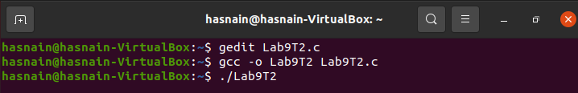

**Code:**

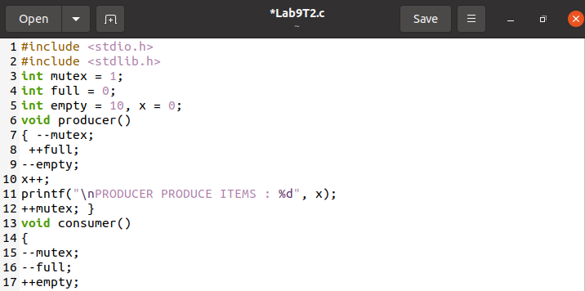

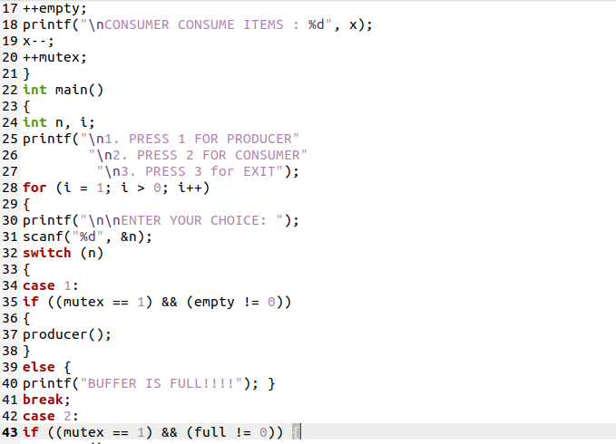

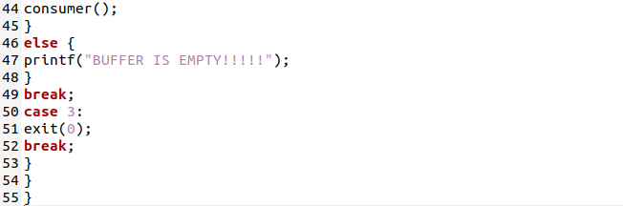

**Output:**

